Вид страницы MatchapListPage
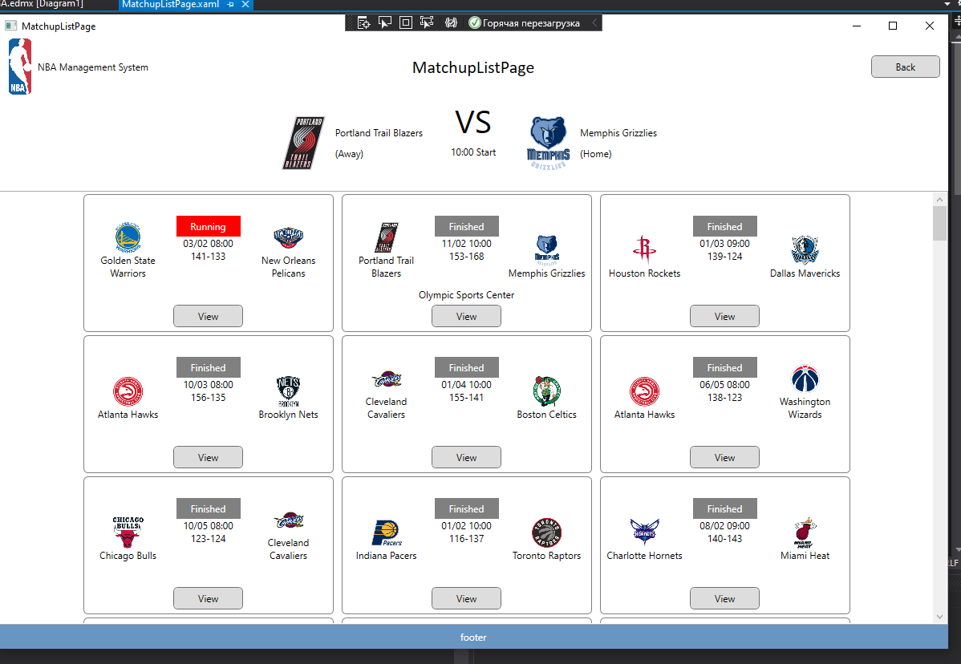
Страница MatchapListPage.xaml
<Grid>
<Grid.RowDefinitions>
<RowDefinition Height="120"></RowDefinition>
<RowDefinition Height="*"></RowDefinition>
</Grid.RowDefinitions>

<Grid Grid.Row="0" Name="GridSelectedMatchup">
<Grid.ColumnDefinitions>
<ColumnDefinition Width="1*"></ColumnDefinition>
<ColumnDefinition Width="Auto"></ColumnDefinition>
<ColumnDefinition Width="1*"></ColumnDefinition>
</Grid.ColumnDefinitions>

<StackPanel Orientation="Horizontal" Grid.Column="0" HorizontalAlignment="Right">
<Image VerticalAlignment="Center" Width="70" Height="70"
Source="{Binding TeamAway.Logo}"></Image>
<StackPanel VerticalAlignment="Center">
<Label Content="{Binding TeamAway.TeamName}"></Label>
<Label>(Away)</Label>
</StackPanel>
</StackPanel>
<StackPanel Margin="30,0" Orientation="Vertical" Grid.Column="1">
<Label FontSize="40">VS</Label>
<TextBlock Text="{Binding Starttime, StringFormat={}{0:HH:mm 'Start'}}"></TextBlock>
</StackPanel>
<StackPanel Orientation="Horizontal" Grid.Column="2">
<Image VerticalAlignment="Center" Width="70" Height="70" Source="{Binding TeamHome.Logo}"></Image>
<StackPanel VerticalAlignment="Center">
<Label Content="{Binding TeamHome.TeamName}"></Label>
<Label>(Home)</Label>
</StackPanel>
</StackPanel>
</Grid>

<ListView Grid.Row="1" Name="ListMatchups" ScrollViewer.HorizontalScrollBarVisibility="Disabled">
<ListView.ItemsPanel>
<ItemsPanelTemplate>
<WrapPanel HorizontalAlignment="Center"></WrapPanel>
</ItemsPanelTemplate>
</ListView.ItemsPanel>
<ListView.ItemTemplate>
<DataTemplate>
<Border Padding="5" CornerRadius="5" BorderThickness="1" BorderBrush="Gray">
<Grid Width="300" Height="160">
<Grid.ColumnDefinitions>
<ColumnDefinition></ColumnDefinition>
<ColumnDefinition></ColumnDefinition>
<ColumnDefinition></ColumnDefinition>
</Grid.ColumnDefinitions>
<Grid.RowDefinitions>
<RowDefinition Height="*"></RowDefinition>
<RowDefinition Height="60"></RowDefinition>
</Grid.RowDefinitions>

<StackPanel VerticalAlignment="Bottom" Orientation="Vertical" Grid.Column="0" Grid.Row="0">
<Image Width="40" Height="40" Source="{Binding TeamAway.Logo}"></Image>
<TextBlock Text="{Binding TeamAway.TeamName}" TextWrapping="Wrap" TextAlignment="Center"></TextBlock>
</StackPanel>
<StackPanel VerticalAlignment="Bottom" Orientation="Vertical" Grid.Column="2" Grid.Row="0">
<Image Width="40" Height="40" Source="{Binding TeamHome.Logo}"></Image>
<TextBlock Text="{Binding TeamHome.TeamName}" TextWrapping="Wrap" TextAlignment="Center"></TextBlock>
</StackPanel>
<StackPanel VerticalAlignment="Center" Orientation="Vertical" Grid.Row="0" Grid.Column="1">
<Label Foreground="White" Content="{Binding StatusString}" Background="{Binding StatusColor}" Width="80" HorizontalContentAlignment="Center"></Label>
<TextBlock Text="{Binding Starttime, StringFormat={}{0:MM/dd HH:mm}}" HorizontalAlignment="Center"></TextBlock>
<TextBlock HorizontalAlignment="Center">
<TextBlock.Text>
<MultiBinding StringFormat="{}{0}-{1}">
<Binding Path="Team_Away_Score"></Binding>
<Binding Path="Team_Home_Score"></Binding>
</MultiBinding>
</TextBlock.Text>
</TextBlock>
</StackPanel>
<StackPanel Orientation="Vertical" Grid.Row="1" Grid.ColumnSpan="3" VerticalAlignment="Bottom">
<Label Content="{Binding Location}" HorizontalAlignment="Center"></Label>
<Button Content="View" Click="ShowSelectedMatchup" Style="{StaticResource Graybutton}" HorizontalAlignment="Center"></Button>
</StackPanel>
</Grid>
</Border>
</DataTemplate>
</ListView.ItemTemplate>
</ListView>
</Grid>
Страница MatchapListPage.xaml.cs
public partial class MatchupListPage : Page
{

public MatchupListPage()
{
InitializeComponent();
NBAShot_03Entities context = new NBAShot_03Entities();
ListMatchups.ItemsSource = context.Matchups.ToList();
}

private void ShowSelectedMatchup(object sender, RoutedEventArgs e)
{
Matchup selectedMatchup = (sender as Button).DataContext as Matchup;
GridSelectedMatchup.DataContext = selectedMatchup;
}
}
Matchap.cs
namespace BasketbolGaliullina
{
using System;
using System.Collections.Generic;
using System.Windows.Media; //подключаем ссылку

public partial class Matchup
{
public int MatchupId { get; set; }
public int SeasonId { get; set; }
public int MatchupTypeId { get; set; }
public int Team_Away { get; set; }
public int Team_Home { get; set; }
public System.DateTime Starttime { get; set; }
public int Team_Away_Score { get; set; }
public int Team_Home_Score { get; set; }
public string Location { get; set; }
public int Status { get; set; }
public string CurrentQuarter { get; set; }

public virtual Season Season { get; set; }
public virtual MatchupType MatchupType { get; set; }
public virtual Team TeamAway { get; set; }
public virtual Team TeamHome { get; set; }
// создаем сами для обработки информации
public string StatusString
{
get
{
switch (Status)
{
case -1:
return "Not Start";
case 0:
return "Running";
case 1:
return "Finished";
default:
return "?????";
}
}
}
public SolidColorBrush StatusColor
{
get
{
switch (Status)
{
case -1:
return Brushes.LightBlue;
case 0:
return Brushes.Red;
case 1:
return Brushes.Gray;
default:
return Brushes.Green;
}
}
}
}
}

